**SessionManagement Using Cookies:**

**CookieDemo.html:**

<!DOCTYPE html>

<html>

<head>

<meta charset=*"ISO-8859-1"*>

<title>Insert title here</title>

</head>

<body>

<form action=*"CookieExample"*>

<b>Select the shirt</b> <select name=*shirt*>

<option value=*"Peter"*>Peter England</option>

<option value=*"Arrow"*>Arrow</option>

<option value=*"Van"*>VanHussain</option>

</select> <select name=*book*>

<option value=*"JCR"*>JCR</option>

<option value=*"RMI"*>RMI</option>

<option value=*"Van"*>VanHussain</option>

</select><br>

<br> <input type=*submit* value=*"ADD ITEMS TO CART"*>

</form>

</body>

</html>

*CookieExample.java:*

**package** com.oja.model;

**import** java.io.IOException;

**import** java.io.PrintWriter;

**import** javax.servlet.RequestDispatcher;

**import** javax.servlet.ServletException;

**import** javax.servlet.annotation.WebServlet;

**import** javax.servlet.http.Cookie;

**import** javax.servlet.http.HttpServlet;

**import** javax.servlet.http.HttpServletRequest;

**import** javax.servlet.http.HttpServletResponse;

/**

* Servlet implementation class CookieExample

*/

@WebServlet("/CookieExample")

**public** **class** CookieExample **extends** HttpServlet {

**static** **int** *i*=1;

**static** **int** *j*=1;

**protected** **void** service(HttpServletRequest request, HttpServletResponse response) **throws** ServletException, IOException {

// **TODO** Auto-generated method stub

response.setContentType("text/html");

PrintWriter out = response.getWriter();

String shirt=request.getParameter("shirt");

String book=request.getParameter("book");

Cookie c1=**new** Cookie("Shirt"+*i*,shirt);

Cookie c2=**new** Cookie("book"+*j*,book);

response.addCookie(c1);

response.addCookie(c2);

*i*++;

*j*++;

out.println("<h3>Items in the Shoping cart are</h3>");

out.println("<h3>"+c1.getName()+":"+shirt+"</h3>");

out.println("<h3>"+c2.getName()+":"+book+"</h3>");

Cookie c[]=request.getCookies();

**if**(c!=**null**) {

**for**(**int** i=0;i<c.length;i++) {

out.println("<h3>"+c[i].getName()+":"+c[i].getValue()+"</h3>");

}

}

RequestDispatcher rd=request.getRequestDispatcher("/CookieDemo.html");

rd.include(request, response);

out.close();

}

}

*Output:*

*In Ecllipse Browser:*

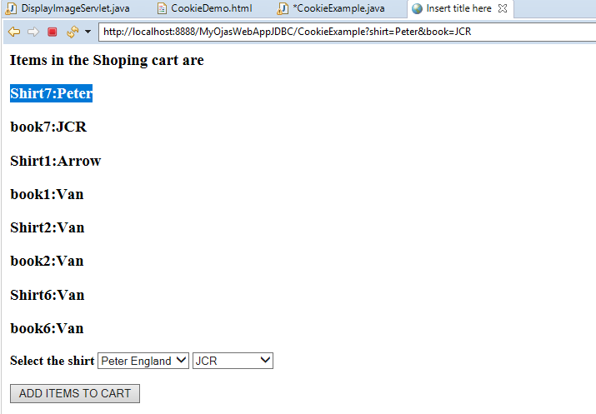

**In another Browser:**

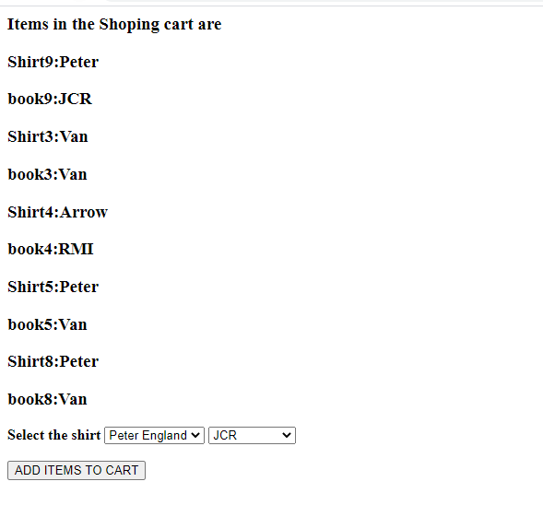

*ok*